

**DEPARTMENT OF COMPUTER ENGINEERING**

**SRTTC’s**

**Suman Ramesh Tulsiani Technical Campus, Faculty of Engineering, Kamshet**

## A REPORT ON

**BLOGGING WEBSITE WITH FIREBASE**

**AUTHENTICATION**

SUBMITTED TO THE SAVITRIBAI PHULE PUNE UNIVERSITY, PUNE IN THE FULFILLMENT OF THE REQUIREMENTS

FOR THE WEB TECHNOLOGY MINI PROJECT

**BACHELOR OF ENGINEERING (COMPUTER ENGINEERING)**

## SUBMITTED BY

SREEKRISHNA BIGALA GR No 221210



# CERTIFICATE

This is to certify that the project report entitles

## “BLOGGING WEBSITE”

Submitted by

SREEKRISHNA BIGALA GR No : 221210

is a bonafide student of this institute and the work has been carried out by him/her under the supervision of **Prof. V.Y.Bhamare** and it is approved for the fulfillment of the requirement of Mini Project in Web Technology subject.

|  |  |  |
| --- | --- | --- |
| **Prof. V.Y.Bhamare** | **Dr. Amruta Surana** | **Prof. (Dr.) J.B.Sankpal** |
| Project Coordinator | Head of Computer Engineering | Principal SRTTC-FoE, Kamshet |

Place : Pune Date :

# ACKNOWLEDGEMENT

I would like to express my sincere gratitude to all those who supported me during the development of the project,

"Blogging Website with Firebase Authentication."

I am especially thankful to my project guide, [Insert Guide’s Name], for their valuable guidance, continuous

feedback, and encouragement throughout the project. Their expertise and insights were instrumental in shaping

the direction and outcome of this work.

I would also like to thank the Department of Computer Engineering, [Insert College Name], for providing the

necessary infrastructure, academic environment, and resources that facilitated the smooth execution of this

project.

I acknowledge the contribution of various open-source platforms and technologies including Firebase, jQuery,

PHP, MySQL, and JavaScript. These tools played a significant role in implementing user authentication, frontend

design, and backend functionalities such as data tracking and asynchronous operations.

This project has provided me with a valuable opportunity to apply theoretical concepts to a practical application

and gain hands-on experience in full-stack web development.

# ABSTRACT

This project presents the design and development of a blogging website frontend that emulates the core functionalities of popular online publishing platforms like Medium. The system is built using HTML, CSS, JavaScript, PHP, MySQL, and jQuery-AJAX for seamless frontend and backend interaction. To enhance user accessibility and security, Firebase Authentication is integrated to enable sign-in and sign-up via Google and Facebook accounts.

The website allows users to log in, publish blogs, and interact with content in a simple and intuitive interface. Total user visits and blog views are dynamically tracked and updated using asynchronous calls through jQuery-AJAX and stored in a MySQL database via PHP scripts. This implementation showcases how modern web technologies can be effectively combined to build an interactive and functional web application.

The project emphasizes responsive design, real-time data handling, and secure authentication, making it a robust prototype for a full-scale blogging platform. It serves as a foundation for further enhancements such as comment sections, blog categorization, search functionality, and user dashboards.

TABLE OF CONTENTS

**LENSKART CLONE**

|  |  |  |  |  |
| --- | --- | --- | --- | --- |
| **Sr. No.** | | **Title of Chapter** | | **Page No.** |
| **01** | | **Introduction** | |  |
|  | 1.1 | Background information about the project | |  |
|  | 1.2 | Objectives of the project | |  |
|  | 1.3 | Scope and limitations | |  |
|  | 1.4 | Importance and relevance of the project | |  |
| **02** | | **Literature Survey** | |  |
|  | 2.1 | Overview of existing literature or similar projects relevant to  your topic | |  |
|  | 2.2 | Discussion of technologies, frameworks, or methodologies used in similar projects | |  |
| **03** | | **Software Requirements Specification** | |  |
|  | 3.1 | Overview of existing literature or similar projects relevant to your topic | |  |
|  | 3.2 | Discussion of technologies, frameworks, or methodologies used in similar projects | |  |
|  | 3.3 | System Requirements | |  |
|  |  | 3.3.1 | Database Requirements |  |
|  |  | 3.3.2 | Software Requirements (Platform Choice) |  |
|  |  | 3.3.3 | Hardware Requirements |  |
| **04** | | **Methodology** | |  |
|  | 4.1 | Description of the approach or methodology used to carry out the project | |  |
|  | 4.2 | Explanation of the tools, technologies, and frameworks utilized | |  |
|  | 4.3 | Details of the development process, including design,  implementation, and testing | |  |
|  | 4.4 | Entity Relationship Diagrams | |  |
|  | 4.5 | UML Diagrams | |  |
| **05** | | **Results** | |  |
|  | 5.1 | Project Code (Any one module) | |  |
|  | 5.2 | Presentation of the outcomes or results of the project (**Screen**  **Shots**) | |  |
|  | 5.3 | Data analysis, if applicable | |  |

|  |  |  |  |  |  |  |
| --- | --- | --- | --- | --- | --- | --- |
| **06** | | **Results** | | | |  |
|  | 6.1 | Outcomes | | | |  |
|  | 6.2 | Screen Shots | | | |  |
| **07** | | **Conclusions** | | | |  |
|  | 7.1 | Summary of the key findings and outcomes | | | |  |
|  | 7.2 | future work or areas of further research | | | |  |
|  | 7.3 | Applications | | | |  |
| **08** | |  | **References:** |  | |  |
|  | 8.1 |  | List of all sources cited in the report, following a specific citation  style (e.g., APA, MLA) | |  |  |
|  | | | |

# Introduction

The rise of online content creation and personal publishing has led to an increasing demand for platforms that allow users to share their thoughts, stories, and knowledge with a global audience. Blogging platforms such as Medium have set a high standard for user-friendly, visually appealing, and functional web applications that support content publishing and reader engagement.

This project aims to develop a blogging website frontend that replicates the essential features of such platforms. The website is built using HTML, CSS, JavaScript, PHP, MySQL, and jQuery-AJAX, focusing on responsiveness, usability, and performance. A key highlight of the project is the integration of Firebase Authentication, enabling users to securely sign up or log in using their Google or Facebook accounts.

The website allows authenticated users to access the platform, while also tracking and displaying total users and total views using backend logic and AJAX communication. The frontend is designed to be clean and intuitive, providing a smooth experience for both content creators and readers.

This project not only demonstrates the integration of multiple web technologies but also serves as a practical implementation of the concepts taught under Web Technology in the SPPU TE Computer Engineering curriculum. It provides a solid foundation for building more complex content management systems and encourages further exploration of web development best practices.

# Objectives

The primary objective of this project is to design and develop a functional frontend for a blogging website that simulates the core features of modern publishing platforms. The key goals of the project are as follows:

1. To develop a responsive and user-friendly blogging website frontend using HTML, CSS, and JavaScript.

2. To implement Firebase Authentication that allows users to sign up, log in, and log out using their Google or Facebook accounts.

3. To design and integrate backend functionality using PHP and MySQL for storing user and blog data securely.

4. To enable asynchronous data interaction using jQuery-AJAX, improving user experience by reducing page reloads.

5. To track and display total views and total users dynamically using AJAX calls and real-time database updates.

6. To create a scalable and maintainable codebase that can be extended with additional features in the future such as comments, search, or categories.

# Scope and limitations

Scope:

1. The project focuses on the frontend design of a blogging website that provides core functionalities similar to platforms like Medium.

2. It allows user authentication via Firebase, supporting Google and Facebook login for secure and convenient access.

3. The system is capable of storing and displaying blog posts, along with tracking total users and total views using MySQL and AJAX.

4. The website interface is designed using HTML, CSS, and JavaScript, making it responsive and user-friendly across different devices.

5. jQuery-AJAX is used for seamless interaction between the frontend and backend, enabling real-time updates without page reloads.

6. The backend is developed using PHP and MySQL, ensuring effective data management for user and blog information.

Limitations:

1. The project does not include full-fledged content management features like editing, deleting posts, or rich text formatting.

2. There is no implementation of user roles (e.g., admin, editor, reader) or access control for different content types.

3. Commenting, liking, and bookmarking functionalities are not included in the current scope.

4. The project is focused on functionality over design, and advanced UI/UX enhancements are minimal.

5. Real-time features such as notifications or live content updates are not part of the current version.

6. Security is handled primarily by Firebase for authentication, but additional backend validation and protection against threats like SQL injection and XSS are minimal in this prototype.

# Importance and relevance

In today’s digital era, blogging has become a powerful tool for communication, knowledge sharing, personal expression, and brand building. With millions of users engaging in content creation and consumption daily, platforms that support easy, accessible, and secure blogging are in high demand.

This project demonstrates the practical application of full-stack web development skills by creating a blogging website frontend that is both interactive and functional. By using Firebase Authentication, it addresses modern expectations for seamless and secure login options via Google and Facebook, which are commonly used in real-world applications.

The integration of jQuery-AJAX and MySQL to handle real-time view and user tracking aligns with common requirements for dynamic content interaction, enabling smoother user experiences and data-driven insights. The project also highlights the importance of asynchronous communication in improving web performance and responsiveness.

From an academic perspective, the project is highly relevant to web technology learning outcomes as prescribed in the SPPU TE Computer syllabus. It bridges the gap between theoretical concepts and their practical implementation, offering hands-on experience in technologies like HTML, CSS, JavaScript, PHP, and Firebase.

In essence, this project serves as a foundational model for developing scalable blogging platforms and can be extended further to include advanced features like comments, categories, user dashboards, and analytics. It provides a real-world perspective on how modern web applications are built, secured, and optimized for user engagement.

# Literature Survey

Modern blogging platforms like Medium have influenced web development by emphasizing responsive design, user authentication, and real-time interactivity. Firebase Authentication provides secure and easy login through Google and Facebook, making it a popular choice for modern applications.

jQuery-AJAX allows asynchronous communication between the frontend and backend, enhancing user experience without page reloads. PHP and MySQL form a reliable backend stack for handling server logic and data storage. HTML, CSS, and JavaScript remain essential for building user-friendly interfaces. These technologies together form the backbone of this project, enabling a functional and interactive blogging platform.

# Technologies, Frameworks, and Methodologies

**Frontend Technologies**

The user interface of the blogging platform is built using HTML, CSS, and JavaScript. HTML provides the structural layout, CSS ensures the design is visually appealing and responsive, and JavaScript adds interactivity. These technologies work together to deliver a seamless and engaging user experience across different devices.

**Frontend Frameworks**

jQuery is used to simplify JavaScript operations, especially DOM manipulation and event handling. AJAX (Asynchronous JavaScript and XML), implemented via jQuery, enables asynchronous server communication. This allows data updates, such as view counts and user tracking, without needing to reload the entire page.

**Backend Technologies**

PHP is used as the server-side scripting language to manage logic, sessions, and server responses. It works closely with MySQL, which serves as the relational database to store user details, blog entries, and site statistics. This combination ensures efficient data processing and secure backend operations.

**Authentication Framework**

Firebase Authentication is integrated to allow users to sign in and sign up using their Google or Facebook accounts. It provides a secure and reliable method for identity management, reducing the need to build a custom authentication system from scratch.

**Version Control Tools**

Git is used for version control, and GitHub hosts the project repository. This enables effective code management, collaboration, and tracking of development changes over time.

**Development Methodology**

The project follows a modular development approach, where the code is organized into reusable and maintainable components. This methodology improves code clarity, eases debugging, and allows future scalability and enhancements.

# Entity Relationship Diagrams

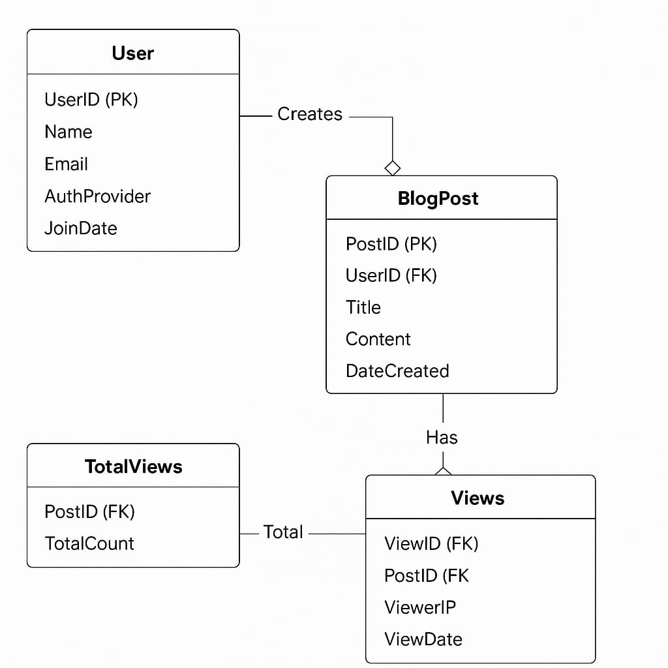

**Results**

Project Code

<!DOCTYPE *html*>

<html *lang*="en">

  <head>

*<!-- Required meta tags always come first -->*

        <meta *charset*="utf-8">

        <meta *name*="viewport" *content*="width=device-width, initial-scale=1, shrink-to-fit=no">

        <meta *http-equiv*="x-ua-compatible" *content*="ie=edge">

        <link *rel*="stylesheet" *href*="https://stackpath.bootstrapcdn.com/font-awesome/4.7.0/css/font-awesome.min.css" *integrity*="sha384-wvfXpqpZZVQGK6TAh5PVlGOfQNHSoD2xbE+QkPxCAFlNEevoEH3Sl0sibVcOQVnN" *crossorigin*="anonymous">

        <script *type*="text/javascript" *src*="http://ajax.googleapis.com/ajax/libs/jquery/1.4.2/jquery.min.js"></script>

        <link *rel*="stylesheet" *href*="style.css">

*<!-- The core Firebase JS SDK is always required and must be listed first -->*

<script *src*="https://www.gstatic.com/firebasejs/8.3.1/firebase-app.js"></script>

<script *src*="https://www.gstatic.com/firebasejs/8.3.1/firebase-auth.js"></script>

<script *src*="https://www.gstatic.com/firebasejs/8.3.1/firebase-analytics.js"></script>

 <script *type*="text/javascript" *src*="http://ajax.googleapis.com/ajax/libs/jquery/1.4.2/jquery.min.js"></script>

          <script *src*="listener.js"></script>

    <title>Blogging</title>

    <script>

    document.**addEventListener**("DOMContentLoaded", function (event) {

    url = window.location.href;

    firebase.**auth**().**onAuthStateChanged**(function (user) {

        login_button = document.**getElementById**("get-started");

        if (user) {

            login_button.innerHTML = "Logout";

            login_button.**setAttribute**('onclick','logout()');

                global_email = user.em

                global_name = user.displayName;

        } else {

            login_button.innerHTML = "Get started";

            login_button.**setAttribute**('onclick','divert()');

        }

    });

});

**$**(document).**ready**(function(){

  $.**ajax**({

    type: 'post',

    url: 'store_rating.php',

    data: {

      view: "pageViews"

    },

**success**: function(response) {

**$**('#count').**html**(response);

    }

  });

  $.**ajax**({

    type: 'post',

    url: 'store_rating.php',

    data: {

      view1: "pageViews1"

    },

**success**: function(response) {

**$**('#user').**html**(response);

    }

  });

});

function logout() {

   firebase.auth().signOut()

   .then(function() {

      alert('Signout Successful');

      console.log('Signout Succesfull');

      window.reload();

   }, function(error) {

      console.log('Signout Failed')

   });

}

    </script>

  </head>

  <body style="background-color: rgb(163, 163, 163); margin: 0px 4.13vw 0px 4.13vw;padding-top: 5px;">

                </div>

    <div style="padding-top:4.5vh;">

      <div style="display:flex; float:right; flex-wrap:wrap;">

        <button class="btn" id="get-started" style="" onclick="divert()">Get started</button>

        <form  action="" style=" ">

      <input class="search" type="text"  placeholder="        Google Search" name="search"><button style="border-radius:0px 5px 5px 0px;" class="search" type="submit"><i class="fa fa-search"></i></button>

      </form>

      </div>

      <div style=" font-family: -apple-system, BlinkMacSystemFont,'Helvetica Neue', sans-serif;  font-size:4.3em; font-weight:bold;">Blogging</div>

        <br>

                        <div class="inner" style="margin-bottom:2px; display:inline-block; " >Total Views : <span id="count"></span> </div>

                      </div>

                        <div class="inner">Total Users :

                          <span id="user"></span>

                        </div>

    <br><br><br>

    <header class="nav">

      <div class="nav-box">

      <a  href="#">Home</a>&nbsp&nbsp

      <a  href="#">Nation</a>&nbsp&nbsp

      <a  href="#">Sports</a>&nbsp&nbsp

      <a  href="#">Politics</a>&nbsp&nbsp

      <a  href="#">Entertainment</a>&nbsp&nbsp

      <a  href="#">Search</a>&nbsp&nbsp

      <a  href="#">Contact Us</a>

      </div>

    </header>

    <hr>

    <table class="table">

      <tr>

        <td id="tab">

                                <img src="img/7.jpg" alt="" style="width:27.5vw; height:26.5vh"></img>

                                <p><h2>Should Twitter Get Rid of Follower Counts?</h2>

                                        <h3>The possibility feels closer than ever</h3>

                                        Cool Neha in All Things Creative<br>

                                        <h4>Jan 9  ·  5 min read</h4></p>

        </td>

        <td >

                                <span><img src="img/1.jpg" alt="" style="float: left;border: 1px solid black;margin: 22px 10px 10px 0px;" width="100" height="100"></img>

                                   <h3>Html, a standardized system for tagging text files to achieve font, colour, graphic, and hyperlink effects on WWW pages.</h3>

                                </span><br>

          <span ><p style=""></p><img src="img/9.jpg" alt="" style="float: left;border: 1px solid black;margin: 0px 10px 10px 0px;" width="100" height="100"></img>

                                <h3>CSS describes how HTML elements are to be displayed on screen, paper, or in other media & control the layout of multiple web pages.</h3>

                                </span><br>

          <span ><p style=""></p><img src="img/4.jpg" alt="" style="float: left;border: 1px solid black;margin: 0px 10px 10px 0px;" width="100" height="100"></img>

                                <h3>Teach yourself the foundations of designing using these links made for learning.--freecodecamp & theodinproject</h3>

                                </span>

        </td>

        <td id="tab">

                                <span class="newpage" onclick="article()"><img src="img/2.jpg" alt=" " style="width:27.5vw; height:26.5vh"></img>

                                    <p><h2>No, That’s Not How You Say It</h2>

                                        <h3>A short personal history of my favorite fast food<br>(<a style="color: initial; font-style: italic; font-size: 1rem; cursor: pointer;" href="more.html">Read more... </a>)</h3>

                                        VIP Singh <br>

                                        <h4>Jan 29 · 8 min read</h4></p>

                                </span>

                </td>

            </tr>

        </table><hr>

        <div >

                <img style="padding-left:0.7vw; width:89.5vw;"src="img/index.png "  alt=" "></img>

        </div><hr>

        <table class="table">

                <tr>

                    <td >

                                    <img src="img/3.jpg" alt=" " style="width:27.5vw; height:26.5vh" ></img>

                                    <p><h2>A few good reasons why you should learn to code</h2>

                                            <h3>You might be wondering if learning to code is something you should...</h3>

                                            Rocky Jagtiani <br>

                                            <h4>Jan 9  ·  5 min read</h4>

                                        </p>

                    </td>

                    <td>

                                    <span><img src="img/1.jpg " alt=" " style="float: left;border: 1px solid black;margin: 22px 10px 10px 0px; " width="100 " height="100 "></img>

                                       <h3>Only buy something that you’d be perfectly happy to hold if the market shut down for 10 years.</h3>

                                    </span><br>

                                    <span><p style=" "></p><img src="img/6.jpg " alt=" " style="float: left;border: 1px solid black;margin: 0px 10px 10px 0px; " width="100" height="100"></img>

                                    <h3>When I figured out how to work my grill, it was quite a moment. I discovered that summer is a completely different experience when you know how to grill.</h3>

                                    </span><br>

                                    <span><p style=" "></p><img src="img/8.jpg " alt=" " style="float: left;border: 1px solid black;margin: 0px 10px 10px 0px; " width="100 " height="100 "></img>

                                    <h3> Chains of habit are too light to be felt until they are too heavy to be broken.</h3>

                                    </span>

                    </td>

                    <td style="align-self: center;">

          <span><img src="img/4.jpg" alt="" style="width:27.5vw; height:26.5vh; "></img>

                                        <p><h2>Deep space radio waves baffle astronomers; aliens not ruled out</h2>

                                            <h3> Every time we see something we’ve never seen before that is an opportu..</h3>

                                            Enzyme Snehar<br>

                                            <h4>Jan 29 · 8 min read</h4></p>

                                    </span>

        </td>

      </tr>

    </table>

    <hr>

    <footer class="footer">

      <div>

          <br>

            <a style="padding:0px 1vw;" href="aboutus.html">About us</a><a style="padding:0px 1vw;">Privacy policy</a><a style="padding:0px 1vw;">Newsletter</a><a style="padding:0px 1vw;">Sitemap</a>

            <h5 class="white-text"><b>FOLLOW US ON</b></h5>

            <a class="fa fa-facebook" id="fa" href="https://www.facebook.com/suvenconsultants/"></a>

            <a class="fa fa-twitter" id="fa"></a>

            <a class="fa fa-google" id="fa" href="https://www.google.co.in/search?nfpr=1&q=suven+consultants&spell=1&sa=X&ved=0ahUKEwidoubh1dXdAhWFNY8KHfrxBZoQBQgpKAA&biw=1366&bih=657#lrd=0x3be7c8afbfffffff:0xcf0cd79d3c52220a,1,,,"></a>

            <a class="fa fa-rss" id="fa"></a>

            <a class="fa fa-youtube" id="fa" href="https://www.youtube.com/user/rockyjagtiani"></a>

          </div>

          <h5>Copyright © 2019 <a>&nbspSuven Consultants and technology pvt ltd</a>&nbsp&nbsp&nbspAll rights reserved

          </h5><br>

    </footer>

    <script>

            function divert() {

              window.location.href = "login.html"

            }

            function article(){

              window.location.href = "more.html"

            }

          </script>

  </body>

</html>

**Presentation of the outcomes or results of the project**

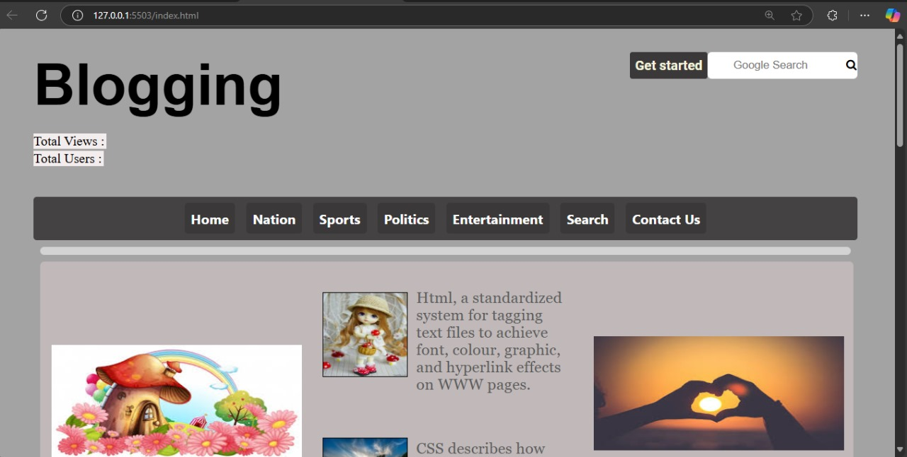

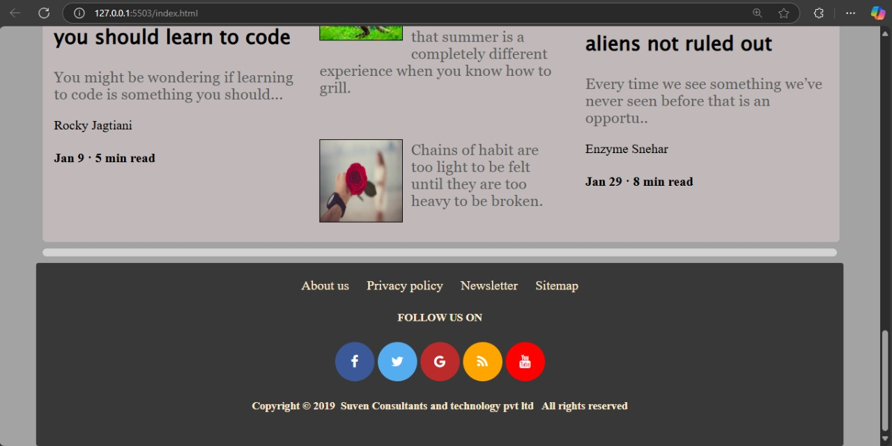

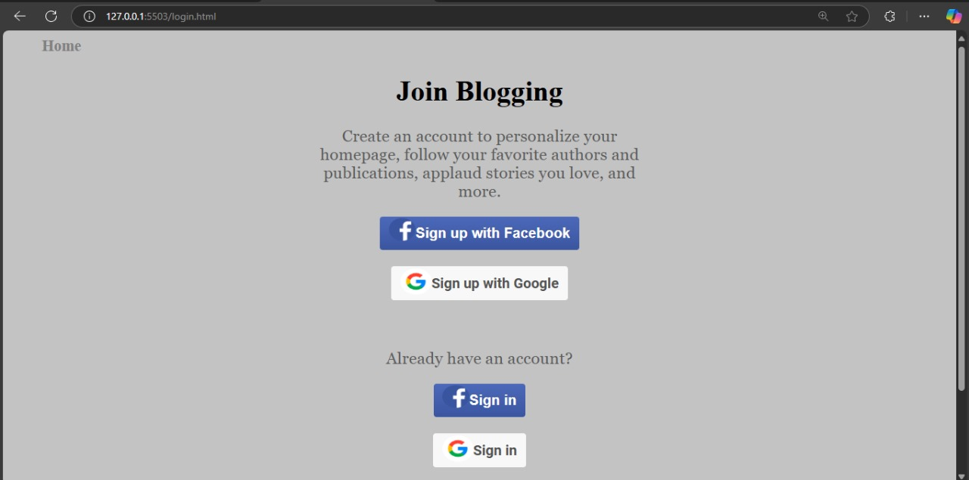

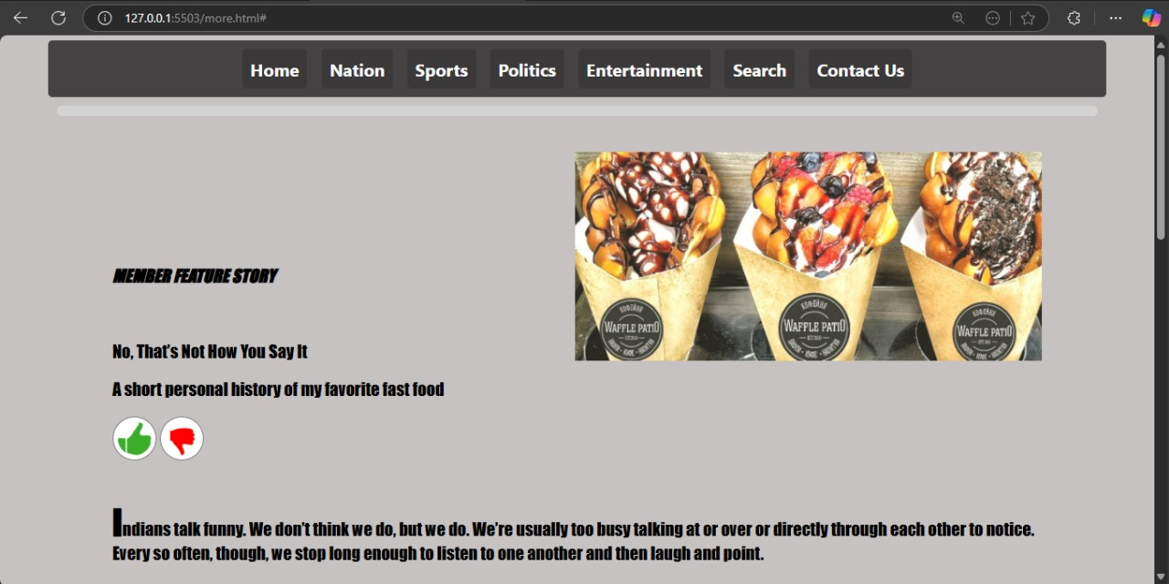



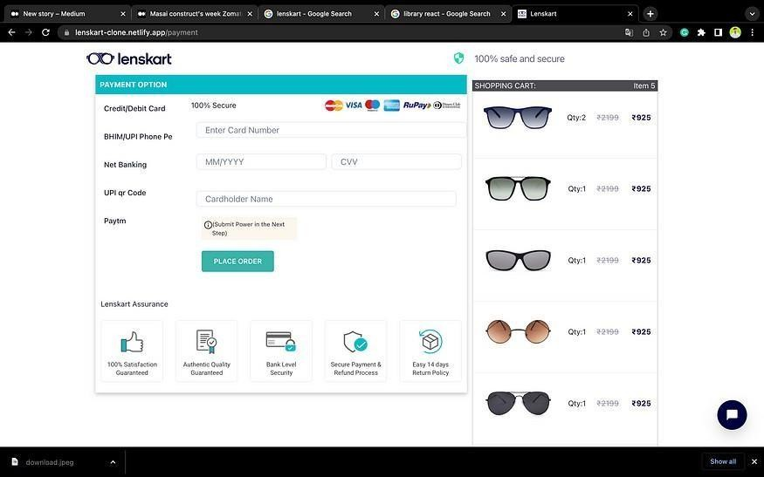

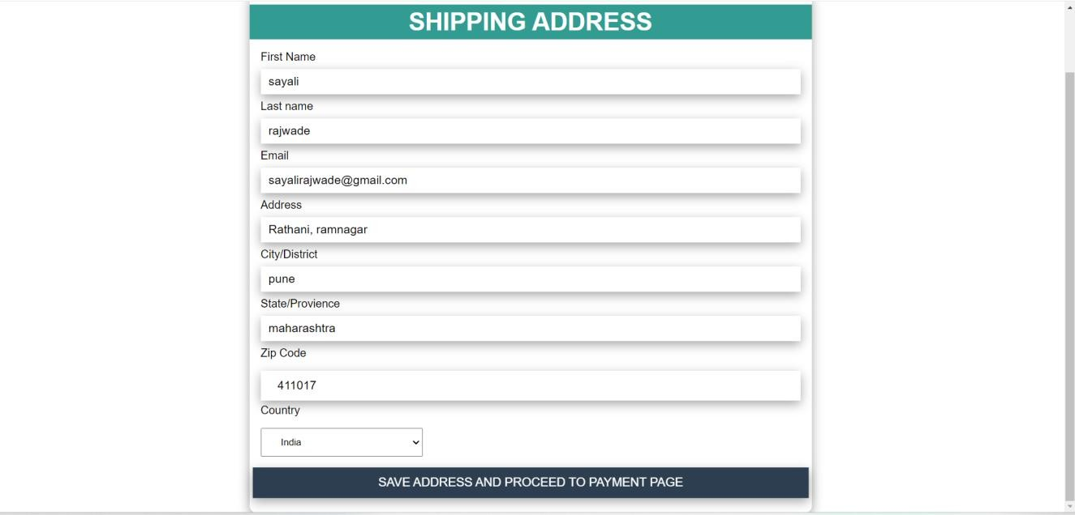

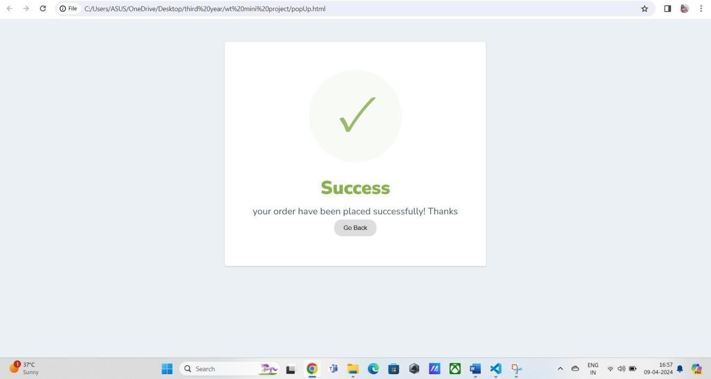

# Conclusions

The development of the blogging website frontend successfully demonstrates the integration of multiple web technologies to create a responsive, interactive, and user-friendly platform. By using HTML, CSS, JavaScript, and jQuery-AJAX, the frontend offers seamless user interaction, while PHP and MySQL handle robust backend logic and data management.

The integration of Firebase Authentication provides a secure and efficient user login system using Google and Facebook. Additionally, features such as real-time user tracking and blog view counts enhance the functionality and usability of the platform. Overall, this project not only showcases the practical application of full-stack web development but also lays a solid foundation for future enhancements like comment systems, post categorization, and rich media integration.

**References**

1. Blogging Website with HTML, CSS, JS and Firebase

<https://www.irjet.net/archives/V9/i1/IRJET-V9I1174.pdf>

2. Online Blogging System

<https://www.ijprems.com/uploadedfiles/paper/issue_4_april_2024/33328/final/fin_ijprems1713259264.pdf>

3. Dynamic Blogging Platforms with Code Sharing Capability

<https://ymerdigital.com/uploads/YMER230498.pdf>

4. Firebase and MySQL Performances for Data Exchanging with CSV File in PHP-Based Website

<https://www.researchgate.net/publication/344189942_FIREBASE_AND_MYSQL_PERFORMANCES_FOR_DATA_EXCHANGING_WITH_CSV_FILE_IN_PHP-BASED_WEBSITE>

5. Application of Firebase in Android App Development - A Study

<https://www.researchgate.net/publication/325791990_Application_of_Firebase_in_Android_App_Development-A_Study>

6. PHP & MySQL Blog App with Admin Panel Tutorial From Scratch

<https://www.youtube.com/watch?v=I010T-UvmRM>

7. Integrate Firebase with PHP for Real-Time Communication

<https://www.cloudways.com/blog/php-firebase-integration/>

8. Add a Blog to Your Website Using Firebase Firestore (Part 1)

<https://medium.com/@roylevy_28840/add-a-blog-to-your-website-using-firebase-firestore-part-1-2-af7dbfbff826>

9. Firebase-PHP Integration – GitHub Repository

<https://github.com/mradulovic988/firebase-php-integration>

10. Firebase Realtime Database Documentation

<https://firebase.google.com/docs/database>